PILOT CARD

(To be completed by Officer of Watch and handed over to boarding Pilot)

VESSEL: ____________________________ DATE : ____________________________

PLACE : ____________________________ TIME : ____________________________

Cargo onboard _______________________ m/ts

Call sign ________________ Deadweight ________________ m/ts Displacement ______________ m/ts

Draught in m/ft: Forward __________________ Aft __________________ Mid ___________________
__________________________________________________________________________________________

SHIP’S PARTICULARS

LOA: ANCHOR CHAIN, Port: __________ Shackles

LBP: Stbd: __________ Shackles

Breadth: 1 Shackle: ______ Mtrs
Depth:
Draught (summer):
Deadweight:
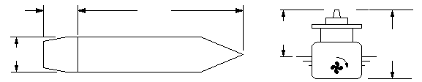
Air draught in: _________ mtrs/______ft_____in
(Please give above dimensions)

Type of Engine: |  | Maximum power:
Maneuvering engine order | R.P.M. | Speed in knots
Maneuvering engine order | R.P.M. | Loaded | Ballast
Full ahead
Half ahead
Slow ahead
Dead slow ahead
Dead slow astern |  | Time limit astern _________ minutes
Slow astern |  | Full ahead to full astern _________ seconds
Half astern |  | Minimum R.P.M. _______ ______knots
Full astern

Master’s name:______________________ | Master’s signature: _____________________

Received by: Pilot’s name: _____________________Signature: ___________________

